# Assignment 2: Setting up AWS Accounts and Launching EC2 Instances

**Name – Tanishq Thuse**

**Roll no – 52**

**PRN – 12310237**

**Sub – Cloud Computing**

**Setting up AWS Accounts and Launching EC2 Instances**

Amazon Web Services (AWS) is a comprehensive cloud platform providing compute, storage, networking, and higher-level services. This assignment familiarizes you with account setup and provisioning a virtual server (EC2).

## Tasks & Step-by-step Instructions

### Task A — Create an AWS Account

1. Open your browser and go to: https://aws.amazon.com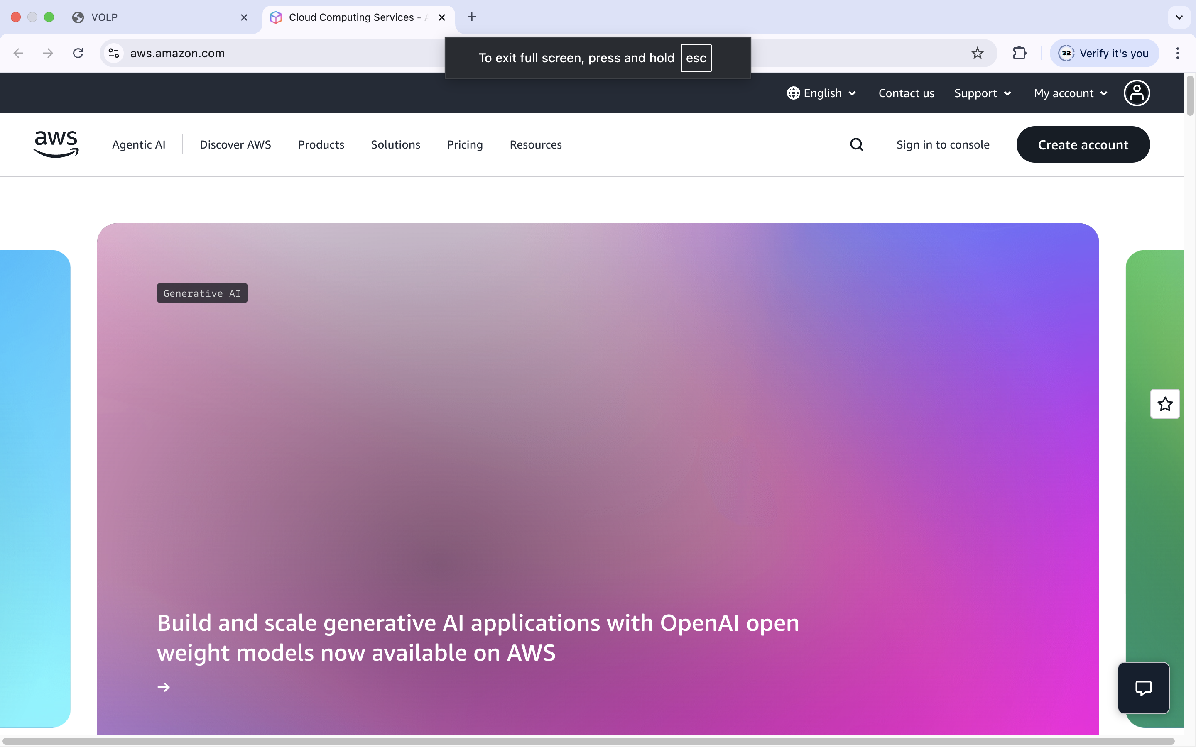  
2. Click Create an AWS Account.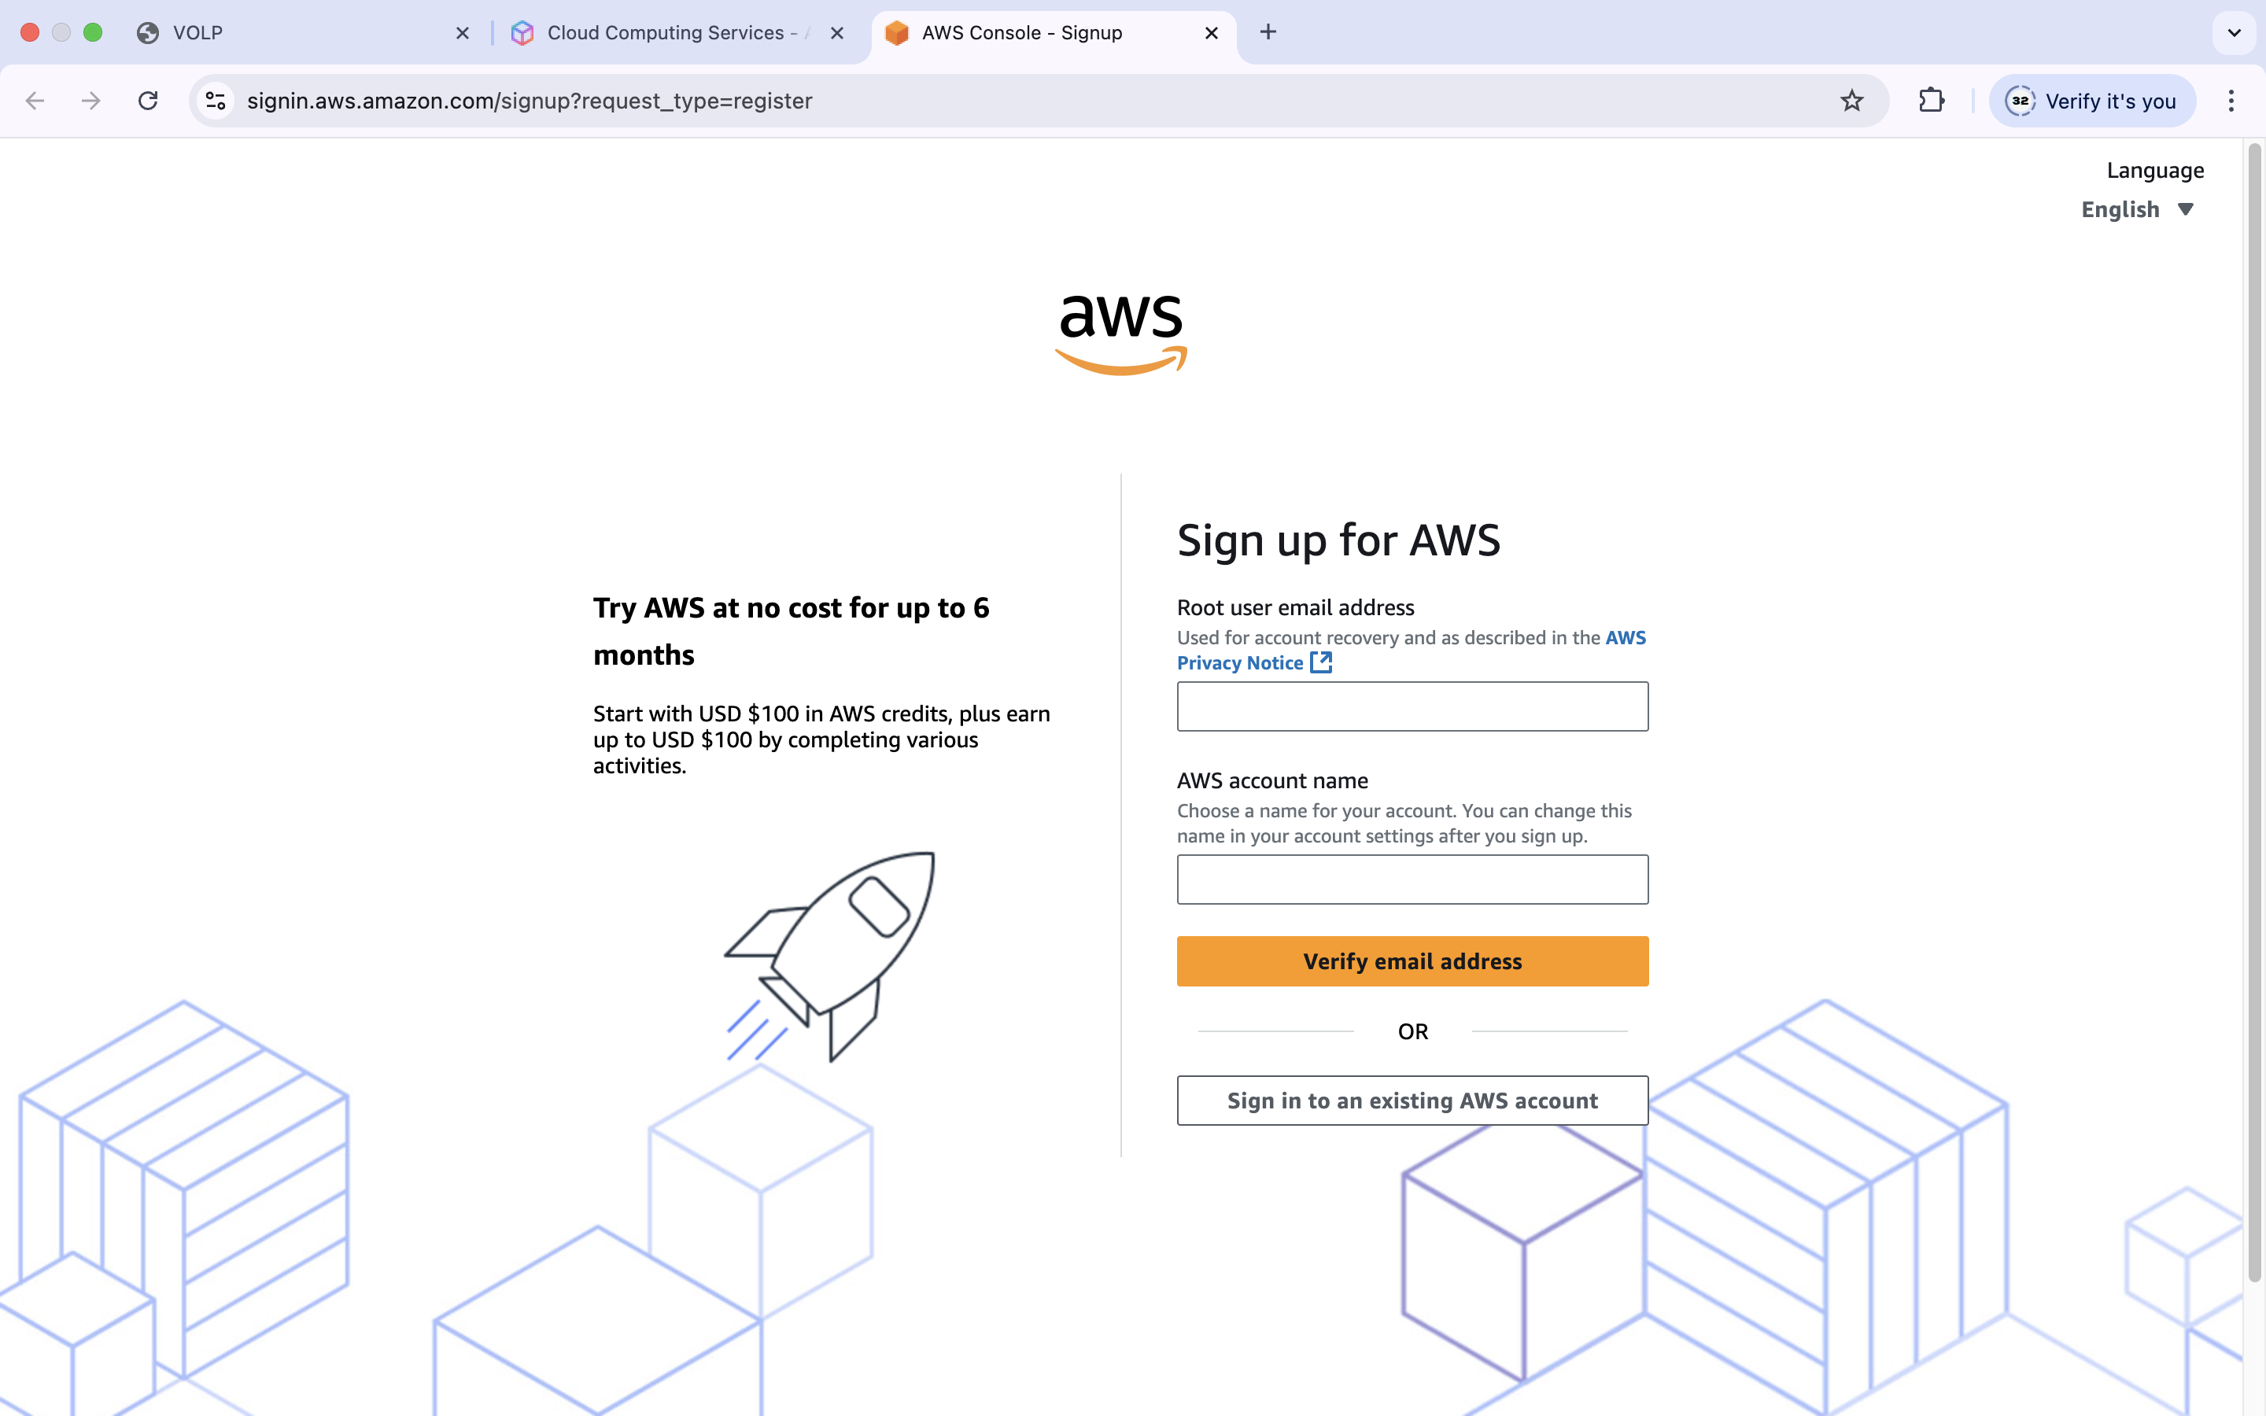  
3. Enter Email, Password, and Account Name.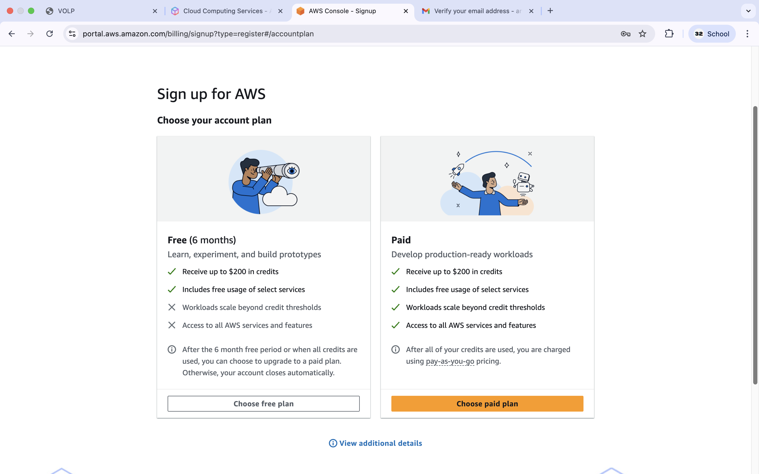  
4. Verify your email using the OTP sent by AWS.  
5. Enter contact information (Personal or Professional).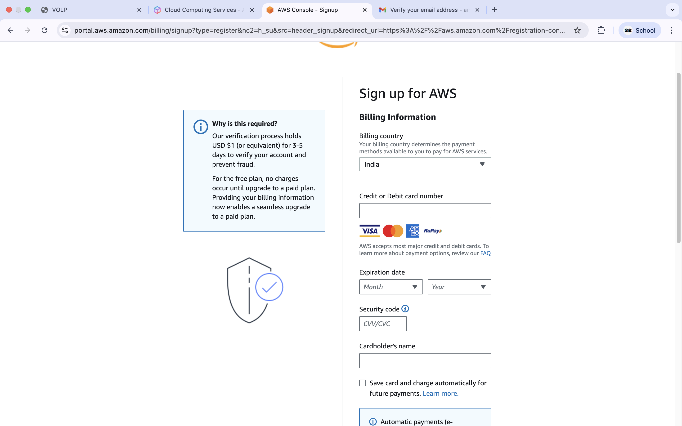  
6. Add payment information (card) — AWS will perform a small temporary charge for verification.  
7. Verify identity using the phone OTP.  
8. Choose the Basic Support plan (Free).  
9. Sign in to the AWS Management Console with your email and password.  
Deliverable A: Screenshot of the AWS Management Console home page after signing in.

### Task B — Launch an EC2 Instance

1. From the AWS Console, search for EC2 and open the EC2 Dashboard.  
2. Click Launch Instance. 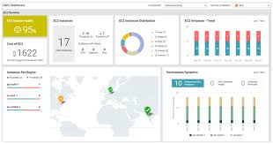

3. Configure the instance:  
 - Name: MyFirstInstance (or another descriptive name)  
 - AMI (Amazon Machine Image): Select Amazon Linux 2 AMI (Free tier eligible)  
 - Instance Type: t2.micro (Free tier eligible)  
 - Key Pair: Create a new key pair; name it and download the .pem file. Keep it safe.  
 - Network: Default VPC/subnet is fine for this assignment.  
 - Security Group: Create or select a security group that allows SSH (port 22). If you plan to host a web server, also allow HTTP (port 80) and HTTPS (443).  
 - Storage: Default (8 GB gp2) is sufficient.

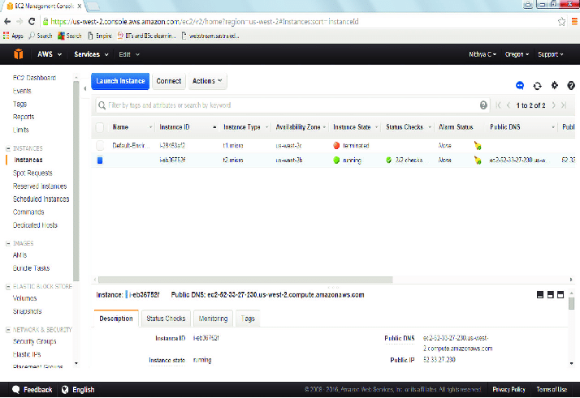

4. Click Launch Instance and confirm.  
5. Wait until the instance reaches running state.